
POSTS AND TELECOMMUNICATIONS
INSTITUTE OF TECHNOLOGY

FACULTY OF INFORMATION TECHNOLOGY



REPORT
Analysis and Design of Information Systems
Student: Đặng Tuấn Phong-B22DCCN612
Class: E22TTNT
Project number: 35
Project name: Store Management

Analysis and Design of Information Systems
Topic 35: Department Store Management

A. Requirements

I. Glossary list
# | English Name | Vietnamese Name | Meaning
Human-related Concepts
1 | Staff | Nhân viên cửa hàng | All employees working in a store.
2 | Customer | Khách hàng | A person who purchases goods or services from the store.
3 | Sale staff | Nhân viên bán hàng | An employee responsible for browsing invoices online, packing and delivering to delivery staff
4 | Management staff | Quản lý cửa hàng | The person in charge of overseeing the entire store operation.
5 | Delivery staff | Nhân viên giao hàng | Employees responsible for transporting goods from the store or warehouse to customers or other locations.
6 | Supplier | Nhà cung cấp hàng hóa | A company or individual that provides products to the store for

 |  |  |  |  |  | resale.
7 |  | Member |  | Thành viên |  | Members in the store program. Can have some exclusive benefits upon registering.
8 |  | ID |  | Định danh, nhận dạng |  | A series of numbers and characters that used to differentiate between objects of the same kind
9 |  | Package |  | Bưu kiện |  | A wrapped or boxed item for storage or delivery.
10 |  | Container |  | Thùng chứa |  | An object used to hold or store something.
11 |  | Report |  | Báo cáo |  | Some sort of information that are summarized and re-organized for research purposes
12 |  | Statistic |  | Số liệu |  | A numerical summary for an object so that staff can get all the attribute of that object
13 |  | Transaction |  | Giao dịch |  | The act of exchange goods and money between the store and the customer
14 |  | Bill |  | Hóa đơn cửa hàng |  | A statement of money owed for goods or services
15 |  | Invoice |  | Hóa đơn mua hàng |  | A detailed bill listing purchased items and their costs.
16 |  | Item |  | Mặt hàng |  | Individual products that the store deals with
17 |  | Store |  | Cửa hàng |  | Business or retail entity that sells items to sub-agents
18 |  | Storage |  | Kho hàng |  | Location where items are kept before being sold or used
19 |  | Quantity |  | Số lượng |  | The number of units of an item being imported, exported, or stored.
20 |  | Unit price |  | Giá đơn vị |  | The cost of a single unit of an item
21 |  | Total price |  | Giá tổng |  | The total cost for a given quantity of an item.
22 |  | Role |  | Chức vụ |  | A specific function or position assigned to a user.
23 |  | Revenue |  | Thu nhập |  | The total amount of money earned from sales
24 |  | Record |  | Bản ghi |  | A stored piece of data in the system
25 |  | Shipment |  | Lô hàng |  | A batch of items being transported
Activity-related Concepts
26 | Purchase |  | Mua |  | Customers pay an amount of money to receive some wanted items from the store
27 | Import |  | Nhập hàng |  | Store contact with the suppliers to refill their stock by buying a large amount of goods
28 | Export |  | Xuất hàng |  | Store sell their goods in large batches to other sub-agents or distributors
29 | Sell |  | Bán |  | Store trade their goods to customers to earn an amount of money
30 | Sales Report |  | Báo cáo bán hàng |  | Summarize sales performance over a specific period for business analysis.
31 | Order |  | Đặt hàng |  | Requesting products from suppliers to restock inventory.
32 | Restock |  | Nhập hàng bổ sung |  | Replenishing inventory to maintain sufficient stock for sales.
33 | Charge |  | Tính tiền |  | Calculating and requesting the total amount a customer needs to pay
34 | Checkout |  | Thanh toán tại quầy |  | Completing the purchase process and making payments at the cashier
35 | Packing |  | Đóng gói |  | Preparing and packaging products for customer pickup or delivery
36 | Deliver |  | Tự chuyển đến tay khách |  | Personally, handing over purchased items to the customer without using a delivery service
37 | Member register |  | Đăng ký thành viên |  | Customer registers as a member

II. System Description in Natural Language:

1. Objective and Scope
- This is a web application which will be used for the management of a department store, in order to maximize work rate and minimize human error.
- There are 3 groups that can use this application, including: management staff, sale staff, and customers.
- This application supports the management of only one department store.
- This application can be accessed through web browser.

2. Users of the application
There are 3 groups that can use this application:
- Management staff:
  - View all kinds of statistics: imports, exports, customers, items and suppliers
  - Commodity information management
  - Import goods from suppliers, manage supplier information
- Sale staff:
  - Browse invoices online
  - Pack and deliver to delivery staff
- Customers:
  - Register as a member
  - Find and look up product information
  - Order online
  - Track invoice status

3. Functions description
Module 1: Customer register as a member:
A Customer enters the web application The system shows the home interface for customer The customer selects the member registration menu from the web interface The system shows the interface to enter information The customer enters their own information (Username, Password, full name, phone number, email address, address) and click the add button in the interface The system saves the information to the database and inform success to the customer and return to the homepage End successfully.
Module 2: Management staff views item statistics:
A management staff log in to the system The system shows the home interface for management staff The management staff selects the menu to view statistical reports The system shows the interface with many options to view different statistics The management staff selects option view item statistics by revenue The system displays the interface to selects start and end date of the wanted period The management staff selects the start and end date, then clicks on the button view item statistics The system will displays a list consist of all items sold in that period, ordered by total revenue from the most to the least, the list is divided by 4 rows (Item code, Item name, Quantity sold, Total revenue in the selected period) The management staff then can clicks on an item row to view detailed sale records The system will display a list of all the related transactions of that item (Invoice ID, Date issued, Quantity, Unit price. Total price) End successfully.

4. Object related to the application
Customer:
- Username
- Password
- Membership number
- Full Name
- Phone number
- Email address
- Adress
Management staff/ Sale staff/ Delivery staff (Staff):
- Username
- Password
- Role
- Full Name
- Phone number
- Email address
- Adress
Supplier:
- Brand name
- Phone number
- Email address
- Adress
Item:
- Name
- Description
- Stock quantity
- Unit price
InvoiceItem:
- Quantity
- Unit price
- Total amount
Invoice:
- Sale Staff information
- Date issued
- Status
- Customer information
- List of all items customer bought
- Total amount
ImportBill:
- Supplier information
- Date issued
- List of all imported items
- Total amount
ImportBillItem:
- Quantity
- Unit price
- Total amount
Statistics related object:
- Import statistics
- Export statistics
- Customer statistics
- Supplier statistics

5. Relationship among objects
- A customer can have multiple invoices
- An invoice can only belong to a customer
- Each invoice can contains multiple items
- An item can belongs to many different invoices
- A sale staff can pack many invoices
- An invoice can only be packed by a sale staff
- A delivery staff can deliver many invoices
- An invoice can only be delivered by a delivery staff

III. System Description in UML:

1. General UC diagram
Actors: Management staff, Customer, Sale staff, Delivery staff, Supplier
The general use case diagram obtained is:
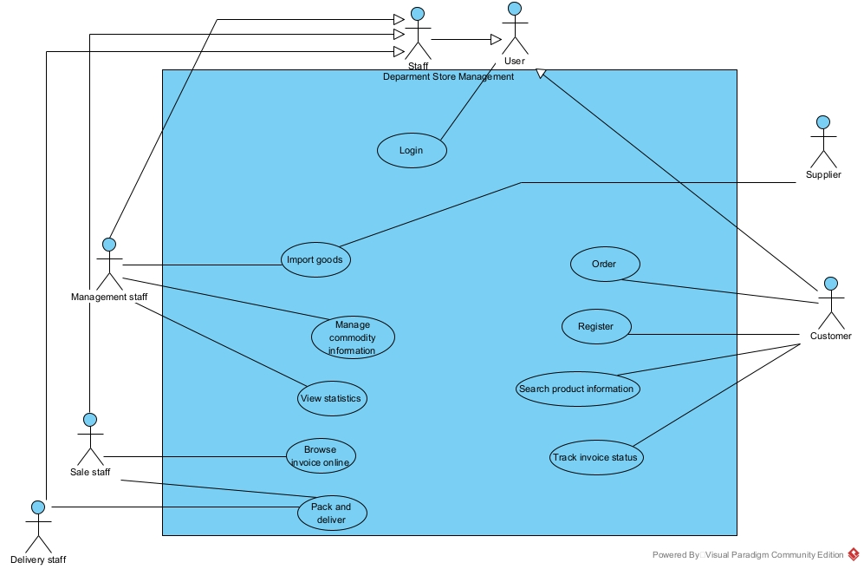
The UC are described as follows:
- Login: This use case enables the user of the system to login to the store management system.
- Register: This use case enables the customer to register as a member of the store to gain access to the store application
- Order: This use case allows the customer to place orders online from the store
- Search product information: This use case enables the customer to find and look up products information online.
- Track invoice status: This use case enables the customer to keep track of their invoice status in the system
- Import goods: This use case enables the management staff to import different goods from the supplier
- Manage commodity information: This use case enables the management staff to manage all the commodity information of the store
- View statistics: This use case enables the management staff to view all the statistics: import, export, customer, supplier in different time periods.
- Browse invoice online: This use case enables the sale staff to find and look up all the invoices in the store online
- Pack and deliver: This use case enables the sale staff to pack an invoice and deliver it to the delivery staff.

2. Detailed UC diagram
Use case: Register:
First, let’s review again the description of this function: A Customer enters the web application The system shows the home interface for customer The customer selects the member registration menu from the web interface The system shows the interface to enter information The customer enters their own information (Username, Password, full name, phone number, email address, address) and click the register button in the interface The system saves the information to the database and inform success to the customer and return to the homepage End successfully.
Main UC: Register
Sub UC:
- View customer homepage
- View registration form
UC diagram:
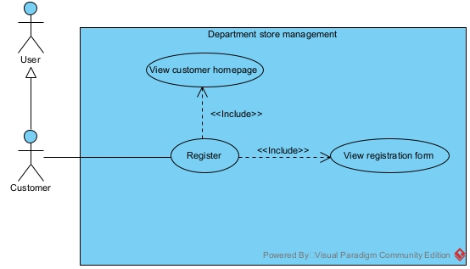
The UC are described as follows:
- View customer homepage: This use case enables the customer to open the homepage when entering the application
- View registration form: This use case enables the customer to view and fill in the registration form with all necessary information
Use case: View item stats
First, let’s review again the description of this function: A management staff log in to the system The system shows the home interface for management staff The management staff selects the menu to view statistical reports The system shows the interface with many options to view different statistics The management staff selects option view item statistics by revenue The system displays the interface to selects start and end date of the wanted period The management staff selects the start and end date, then clicks on the button view item statistics The system will displays a list consist of all items sold in that period, ordered by total revenue from the most to the least, the list is divided by 4 rows (Item code, Item name, Quantity sold, Total revenue in the selected period) The management staff then can clicks on an item row to view detailed sale records The system will display a list of all the related transactions of that item (Invoice ID, SaleStaffID, Date issued, Quantity, Unit price. Total price) End successfully.
Main UC: View item stats
Sub UC:
- Management staff Login
- View management staff homepage
- View item stats by revenue
- View detail sale records

UC diagram:
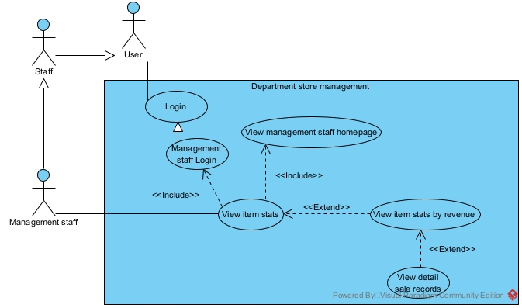
The UC are described as follows:
- Management staff Login: This use case allows management staff to login to the system
- View management staff homepage: This use case enables management staff to open the manager homepage after login to the system
- View item stats by revenue: This use case enables management staff to view a list of items in order of the most total revenue to the least in the selected time period.
- View detail sale records: This use case enables the management staff to view al the detail transactions related to the selected item.

B. Analysis

I. Scenario
Use case | Register
Actor | Customer
Pre-condition | Customers open the store homepage and do not have a member account
Post-condition | Customer successfully register as a member of the store
Main events | 1. Customer A enters the store web application in their browser to register as a member  2. The system shows the store homepage interface with 2 options: Login and register as a member and a search bar with a search button  3. Customer A selects the member registration menu from the web interface  4. The system shows the registration form with all these input fields for the customer to fill in: Username, Password, Full name, Phone number, Email address, Address and a button to confirm.  5. Customer A fill in the form with these information respectively: phongdzfk; 123456; Đặng Tuấn Phong; 0858262492; 24hphon@gmail.com; Hà Đông Hà Nội, then clicks on the confirm button  6. The system ask the customer again for confirmation  7. Customer A clicks confirm  8. The system informs success to the customer and returns to the homepage interface
Exceptional scenario | 5. The information customer filled in are invalid (inappropriate name, duplicate phone number/email address)

Use case | View item stats
Actor | Management staff
Pre-condition | A management staff has a management staff account
Post-condition | The management staff successfully view the statistics of all the items
Main events | 1. Management staff A login to the store web application to view item statistics  2. The management staff homepage appears 2 options: View statistical reports, Import items  3. The management staff then clicks on the “View statistical reports” button  4. The system displays the view stats interface with 4 options: View item stats, View import stats, View customer stats, view supplier stats  5. The management staff clicks on the “View item stats” button  6. The system shows an interface that has: an input date for start date, an input date for end date, a table for item statistics, a “View” button and a “Next” button, with a “Return” button in the end of the page  7. The management staff select the start date as 20/01/2025, the end date as 30/01/2025, and clicks on the “View” button  8. The system displays a list of items, sorted from highest to lowest revenue in that time period:  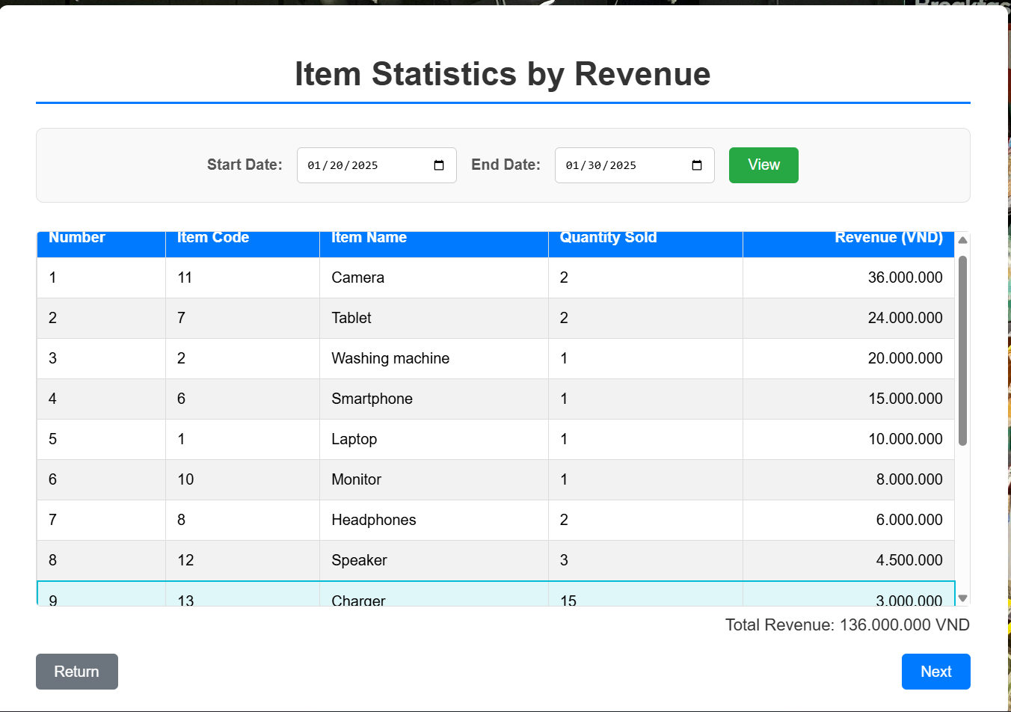  9. The management staff clicks on the “Charger” row, then clicks on the “Next” button  10. The system displays an interface which has a list of detailed statistics of invoices for that item, along with some additional info:  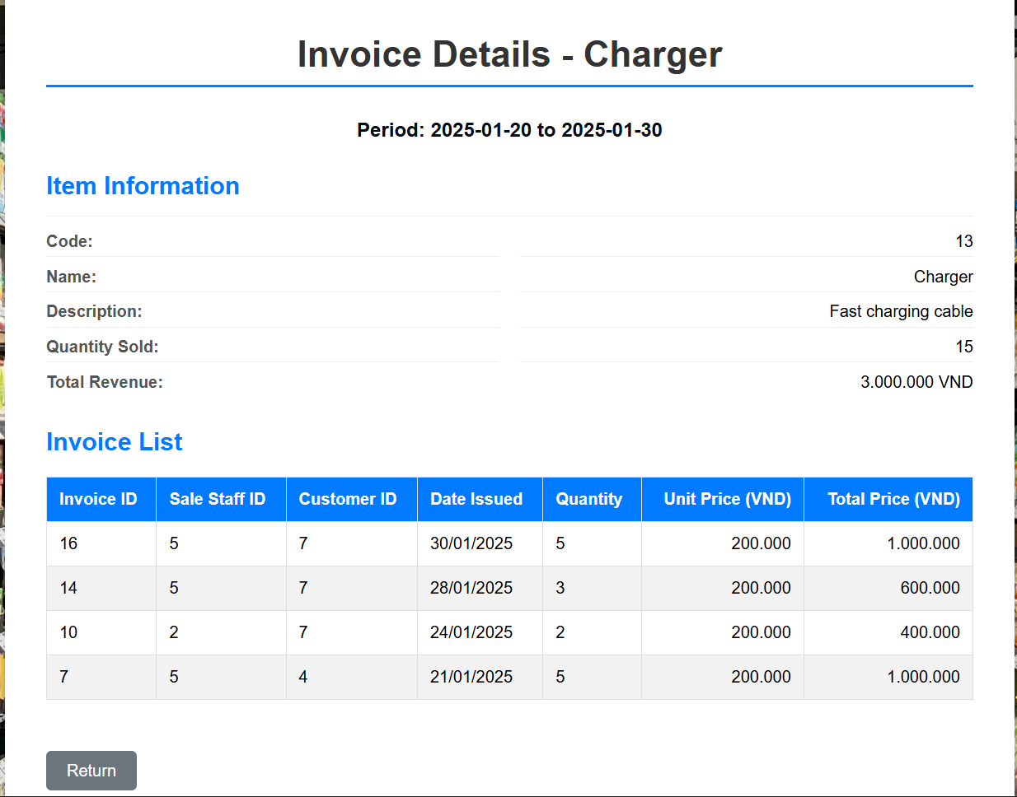  11. End successfully
Exceptional scenario | 1. The login information is invalid  9. There are no revenue records in that period

II. Entity class extraction
Step 1 + 2: Review the standard scenario and extract all nouns
- Management staff
- Customer
- Sale staff
- Delivery staff
- Department store
- System
- Import statistics
- Export statistics
- Customer statistics
- Supplier statistics
- Suppliers
- Information
- Item
- Goods
- Invoice
- Order
- Member
- Product
- Invoice status
- Menu
- Database
- Transaction list
- Report
- Quantity
- Unit price
- Total price
Step 3: Classify all the nouns:
- Management staff need to be managed Class Staff Inherit from Class User (username, password, fullname, phoneNumber, emailAddress, address) with an additional att: Role
- Customer need to be managed class Customer Inherit Class User () with an additional att: Membership number
- Sale staff need to be managed class SaleStaff inherit from Class Staff
- Delivery staff need to be managed class DeliveryStaff inherit from Class Staff
- Department store out of scope reject
- System too abstract reject
- Import statistics need to be manage class ImportStat: (totalQuantity, totalAmount)
- Export statistics need to be manage class ExportStat: (totalQuantity, totalRevenue)
- Customer statistics need to be manage class CustomerStat: (numberOfInvoice, totalAmount)
- Supplier statistics need to be manage class SupplierStat: (numberImporting, totalAmount)
- Suppliers need to be manage class Supplier: (brandName, phoneNumber, emailAddress, address)
- Information too abstract reject
- Item need to be manage class Item: (name, description, stockQuantity, unitPrice)
- Goods same as Item reject
- Invoice need to be managed class Invoice: (dateIssued, totalAmount, status); Because we also import need another Class ImportBill (dateIssued, totalAmount)
- Order same with Invoice reject
- Member too abstract reject
- Product same as Item reject
- Invoice status is an attribute of class Invoice reject
- Menu too abstract reject
- Database out of scope reject
- Transaction list out of scope reject
- Report too abstract reject
- Quantity is an attribute reject
- Unit price is an attribute reject
- Total price is an attribute reject
Step 4+5: quantity and object relationships among classes:
- An Item can appear in many Invoice, and one Invoice can contain many Item The relationship between them is n-n Need an intermediate class InvoiceItem(quantity, unitPrice, TotalAmount) to manage the quantity and unit price for each item in invoice
- An An Item can appear in many ImportBill, and one ImportBill can contain many Item The relationship between them is n-n Need an intermediate class ImportBillItem(quantity, unitPrice, totalAmount) to manage the quantity and unit price for each item in import bill
- A Customer can have multiple Invoice, an Invoice only belong to a Customer The relationship Customer-Invoice is 1-n
- A SaleStaff can pack many Invoice, but one Invoice can only be packed by a SaleStaff The relationship SaleStaff-Invoice is 1-n
- A DeliveryStaff can deliver many Invoice, but one Invoice can only be delivered by a DeliveryStaff The relationship DeliveryStaff-Invoice is 1-n
- A ManagementStaff can process many ImportBill, but one ImportBill can only be processed by a ManagementStaff The relationship ManagementStaff-ImportBill is 1-n
- A Supplier can have multiple ImportBill, but one but one ImportBill can onlylong to a Supplier The relationship Supplier-ImportBill is 1-n
- All the statistics Class are inherited from all their respective Class.
Class Diagram for the whole system:

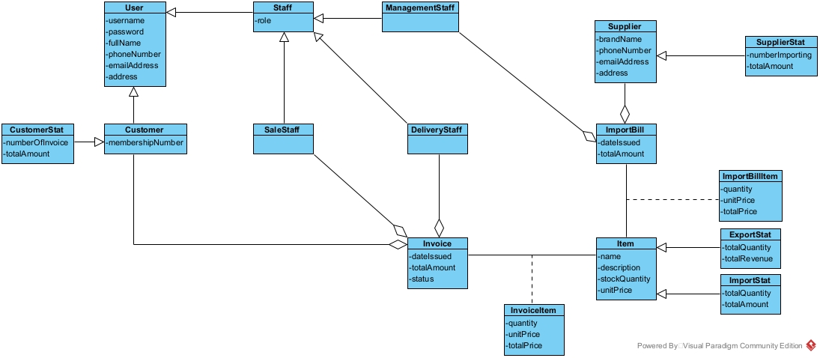

III. Class Diagram (Analysis)
Module Register:
Let’s analyze the Register module:
- Enter the system the homepage interface appears need a Class: HomePageView:
  - Input text for unregistered customers to search information about items in the store inSearch
  - A search button: subSearch
  - A button to Login: subLogin
  - A button to Register: subRegister
- Click on Register Registration form will appear need a Class: RegisFormView:
  - Input text for Username: inUsername
  - Input text for Password: inPassword
  - Input text for Fullname: inFullname
  - Input text for PhoneNumber: inPhoneNumber
  - Input text for EmailAddress: inEmailAddress
  - Input text for Address: inAddress
  - A button to confirm register: subRegister
  - A button to go back to the homepage: subReturn
- After registering, the system needs to save the registration information need a method:
  - Name: saveRegisterInfo()
  - Input: an object of Customer
  - Ouput: boolean
Class Diagram:
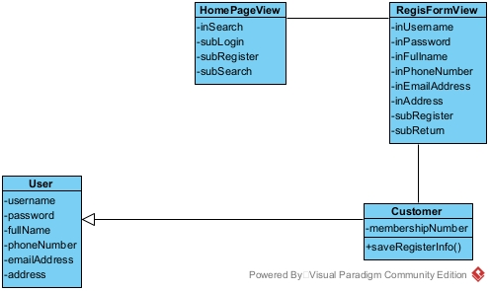

Module View item statistics by revenue:
Let’s review the view item statistics by revenue module:
- Management staff login to the system management staff home page appears need a Class: ManagementStaffHomeView:
  - A button to view statistical report: subViewStatisticalReport
  - A button to import item: subImportItem
- Click on view statistical report Stat interface will appear need a Class: StatView:
  - A button to view item stat by revenue (export stat): subViewItemStat
  - A button to view import stat: subViewImportStat
  - A button to view customer stat: subViewCustomerStat
  - A button to view supplier stat: subSupplierStat
  - A button to return: subReturn
- Click on view item stat Item stat interface will appear need a Class: ItemStatView:
  - Input for start date: inStartDate
  - Input for end date: inEndDate
  - A button to view stat: subView
  - A button to go to next interface: subNext
  - A list of items which could be clicked on to choose a specific item: outsubListItemStat
  - A button to return: subReturn
- Enter the desired start date, end date and click on the view button The system has to query all the export statistics of item Needs a method:
  - Name: getExportStatByDate()
  - Input: Start date and end date
  - Output: List of ExportStat
  - Assigned to entity class: ExportStat
- Click on an item, then click next to view detailed invoice information need a Class: InvoiceView:
  - Display some item information (Item code, Item name, description, total quantity sold, total revenue): outItemInfo
  - A list of invoices related to that item: outListInvoice
  - A return button: subReturn
  - A button to go to management staff homepage: subHome
- The system has to query all the invoices relating to the item in the specified period Needs a method:
  - Name: getInvoiceListOfItem()
  - Input: Start date, end date and item code
  - Output: List of Invoice
  - Assigned to entity class: Invoice
Class Diagram:

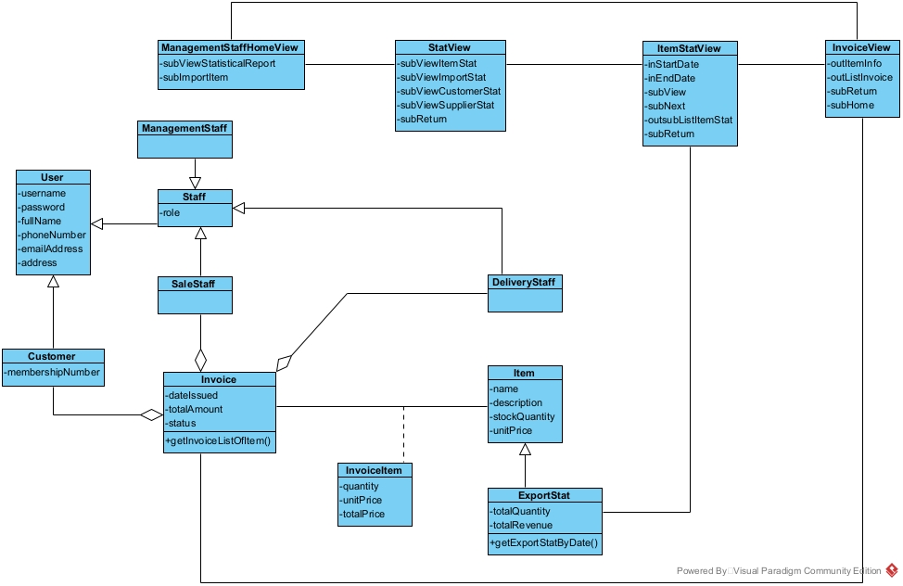

IV. Activity analysis
Module Register:
State Diagram:
- From customer homepage, if the register option is chosen, the system will switch to the register form interface
- From register form interface, if the return option is chosen, the system will return to the previous interface
- From register form interface, if the customer enter information and click confirm, the system will save the registration information End
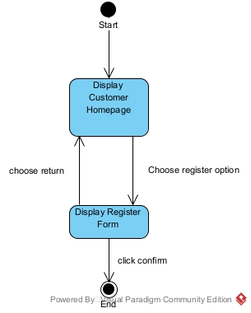
Scenario v2:
1. At the customer homepage, customer chooses the option “Register” to register as a member
2. Class HomePageView calls RegisFormView
3. Class RegisFormView displays itself to the customer
4. Customer fills in all the registration information and clicks register
5. Class RegisFormView calls Class Customer to save registration information
6. Class Customer saves the registration information of the customer
7. Class Customer returns the result to the Class RegisformView
8. Class RegisFormView informs success to the customer

Communication Diagram:
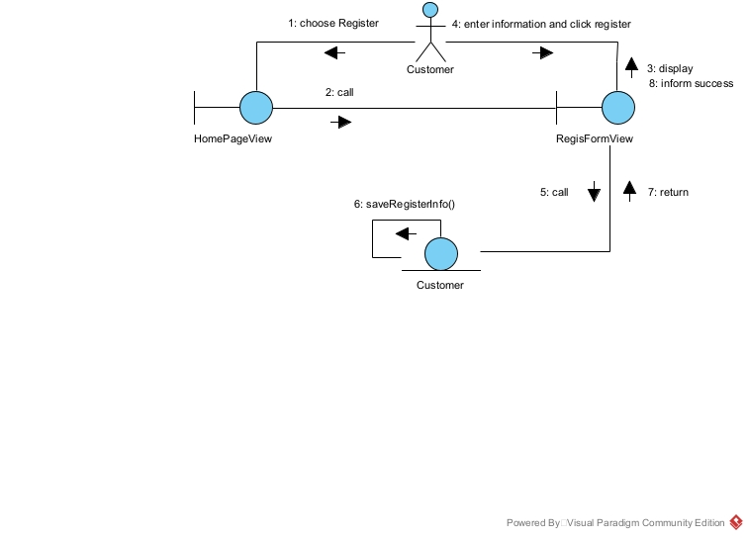Sequence Diagram:
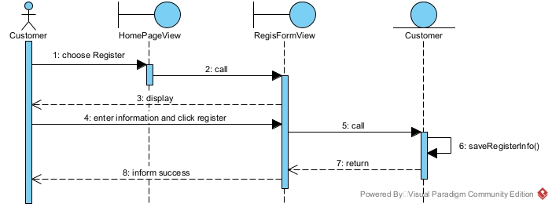

Module View item statistics by revenue:
State Diagram (Analysis):
- From management staff homepage, if the view statistical report option is chosen, the system will switch to the stat interface
- From stat interface, if the view item stat option is chosen, the system will switch to the item stat interface
- From item stat interface, if an item is selected to view detail revenue, the system will switch to the view invoices of an item interface
- From all the interface apart from the homepage, if the return option is chosen, the system will return to the previous interface
- From the invoices of an item interface, if the home option is chosen, the system will return to the homepage

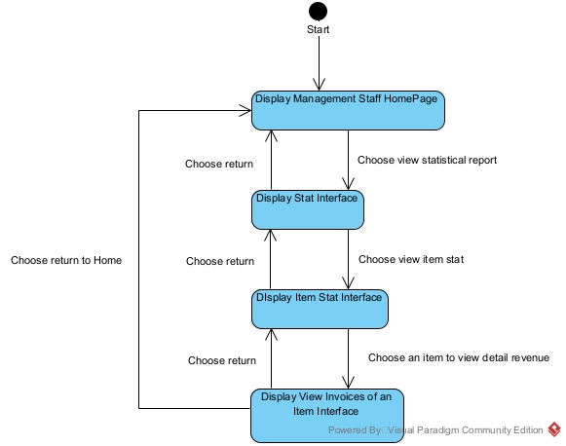
Scenario v2:
1. At the management staff homepage, after login, management staff chooses the option to view statistical reports
2. Class ManagementStaffHomeView calls Class StatView
3. Class StatView displays itself to the management staff
4. Management staff chooses the option to view items stat
5. Class StatView calls Class ItemStatView
6. Class ItemStatView displays itself to the management staff
7. Management staff enters start and end date, then click on View
8. Class ItemStatView calls Class ExportStat to ask for statistics in that period
9. Class ExportStat get all items statistics in that period
10. Class ExportStat returns the result to Class ItemStatView
11. Class ItemStatView displays the result to the management staff
12. Management staff clicks on an item, then click next
13. Class ItemStatView calls Class InvoiceView
14. Class InvoiceView calls Class Invoice to get all invoices statistics related to the selected Item
15. Class Invoice get all the related invoice statistics
16. Class Invoice returns the result to Class InvoiceView
17. Class InvoiceView displays the result to the management staff
Communication Diagram (Analysis):
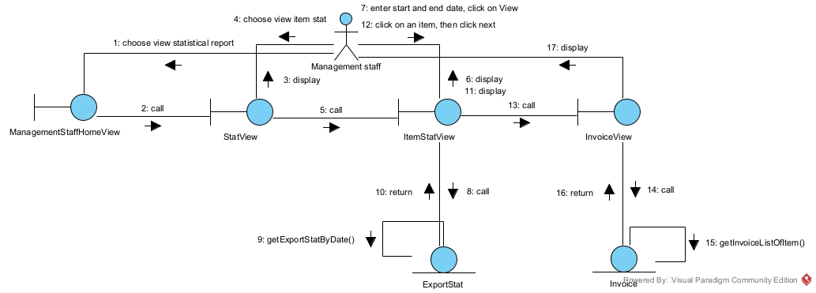
Sequence Diagram (Analysis):
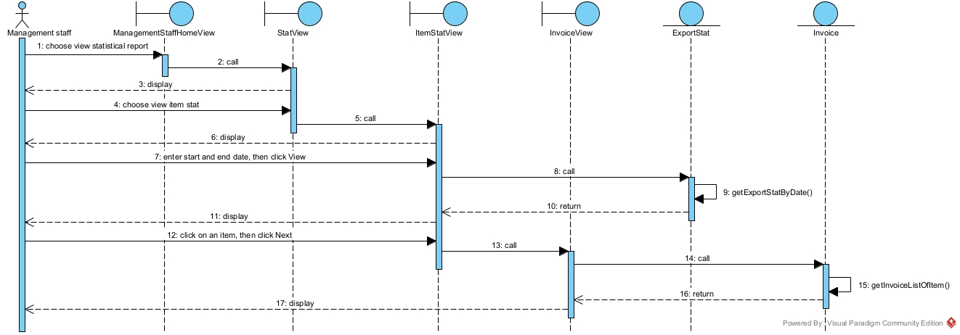

C. Design

I. Entity classes
Step 1: Add the ID attribute for the classes which do not inherit from other classes: User, Invoice, Supplier, Item, InvoiceItem, ImportBill, ImportBillItem
Step 2: Add the type of each attribute in all classes
Step 3: Convert all association relationships into corresponding aggregation/composition
relationships:
- ImportBill + Item ImportBillItem is converted to: ImportBillItem is a component of ImportBill (composition), Item is a component of ImportBillItem (aggregation)
- Invoice + Item InvoiceItem is converted to: InvoiceItem is a component of Invoice (composition), Item is a component of InvoiceItem (aggregation)
Step 4: Add the object attributes which correspond to the aggregation/composition
relationships:
- Customer is a component of Invoice, of type 1-n Invoice has a Customer
- SaleStaff is a component of Invoice, of type 1-n Invoice has a SaleStaff
- DeliveryStaff is a component of Invoice, of type 1-n Invoice has a DeliveryStaff
- InvoiceItem is a component of Invoice, of type n-1 Invoice has a list of InvoiceItem
- Item is a component of InvoiceItem, of type 1-n InvoiceItem has a Item
- Item is a component of ImportBillItem, of type 1-n ImportBillItem has an Item
- Supplier is a component of ImportBill, of type 1-n ImportBill has a Supplier
- ManagementStaff is a component of ImportBill, of type 1-n ImportBill has a ManagementStaff
- ImportBillItem is a component of ImportBill, of type n-1 ImportBill has a list of ImportBillItem

Diagram: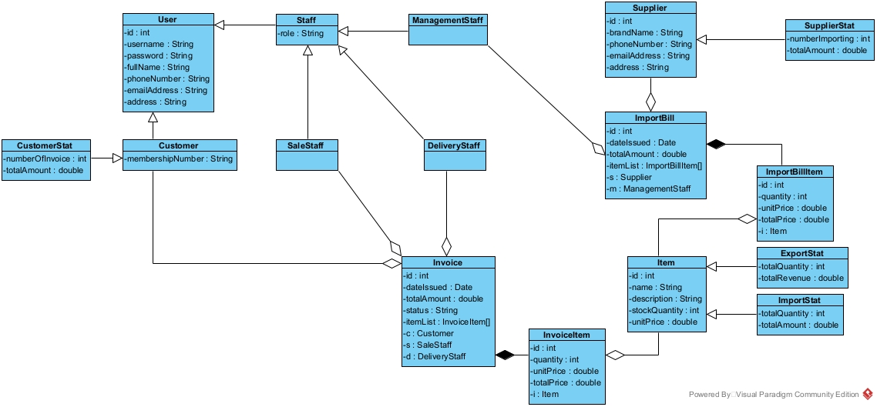

II. Database
Step 1: For each entity class, create a corresponding table
- User tblUser
- Customer tblCustomer
- Staff tblStaff
- SaleStaff tblSaleStaff
- ManagementStaff tblManagementStaff
- DeliveryStaff tblDeliveryStaff
- Invoice tblInvoice
- InvoiceItem tblInvoiceItem
- Item tblItem
- Supplier tblSupplier
- ImportBill tblImportBill
- ImportBillItem tbl ImportBillItem
Step 2: For each entity class, transfer all non-object attributes to contribute as the
columns of the corresponding table:
- tblUser: id, username, password, fullName, phoneNumber, emailAddress, address
- tblCustomer: membershipNumber
- tblStaff: role
- tblInvoice: id, dateIssued, totalAmount, status
- tblInvoiceItem: id, quantity, unitPrice, totalPrice
- tblItem: id, name, description, stockQuantity, unitPrice
- tblSupplier: id, branchName, phoneNumber, emailAddress, address
- tblImportBill: id, dateIssued, totalAmount
- tblImportBillItem: id, quantity, unitPrice, totalPrice
Step 3: Consider the quantity relationships among entity classes. These relationships will
be those among corresponding tables:
- 1 tblUser – 1 tbl Customer
- 1 tblUser – 1 tblStaff
- 1 tblStaff – 1 tblSaleStaff
- 1 tblStaff – 1 tblManagementStaff
- 1 tblStaff – 1 tblDeliveryStaff
- 1 tblCustomer – n tblInvoice
- 1 tblSaleStaff – n tblInvoice
- 1 tblDeliveryStaff – n tblInvoice
- 1 tblInvoice – n tblInvoiceItem
- 1 tblItem – n tblInvoiceItem
- 1 tblItem – n tblImportBillItem
- 1 tblImportBill – n tblImportBillItem
- 1 tblSupplier – n tblImportBill
- 1 tblManagementStaff – n tblImportBill
Step 4: Config the key columns for tables; the ID attribute of each table will be set as the
primary key of that table.
- 1 tblUser – 1 tblCustomer tblCustomer has a foreign key: tblUserid (also primary key)
- 1 tblUser – 1 tblStaff tblStaff has a foreign key: tblUserid (also primary key)
- 1 tblStaff – 1 tblSaleStaff tblSaleStaff has a foreign key: tblUserid (also primary key)
- 1 tblStaff – 1 tblManagementStaff tblManagementStaff has a foreign key: tblUserid (also primary key)
- 1 tblStaff – 1 tblDeliveryStaff tblDeliveryStaff has a foreign key: tblUserid (also primary key)
- 1 tblCustomer – n tblInvoice tblInvoice has a foreign key: tblCustomerid
- 1 tblSaleStaff – n tblInvoice tblInvoice has a foreign key: tblSaleStaffid
- 1 tblDeliveryStaff – n tblInvoice tblInvoice has a foreign key: tblDeliveryStaffid
- 1 tblInvoice – n tblInvoiceItem tblInvoiceItem has a foreign key: tblInvoiceid
- 1 tblItem – n tblInvoiceItem tblInvoiceItem has a foreign key: tblItemid
- 1 tblItem – n tblImportBillItem tblImportBillItem has a foreign key: tblItemid
- 1 tblImportBill – n tblImportBillItem tblImportBillItem has a foreign key: tblImportBillid
- 1 tblSupplier – n tblImportBill tblImportBill has a foreign key: tblSupplierid
- 1 tblManagementStaff – n tblImportBill tblImportBill has a foreign key: tblManagementStaffid
Step 5: Remove redundant attributes:
- Attribute totalAmount from tblInvoice is redundant because it can be calculated from the sum of quantity * unitPrice of each InvoiceItem in Invoice
- Attribute totalAmount from tblImportBill is redundant because it can be calculated from the sum of quantity * unitPrice of each ImportBillItem in ImportBill
- Attribute totalPrice from tblInvoiceItem is redundant because it can be calculated from quantity * unitPrice
- Attribute totalAmount from tblImportBillItem is redundant because it can be calculated from quantity * unitPrice
Diagram:
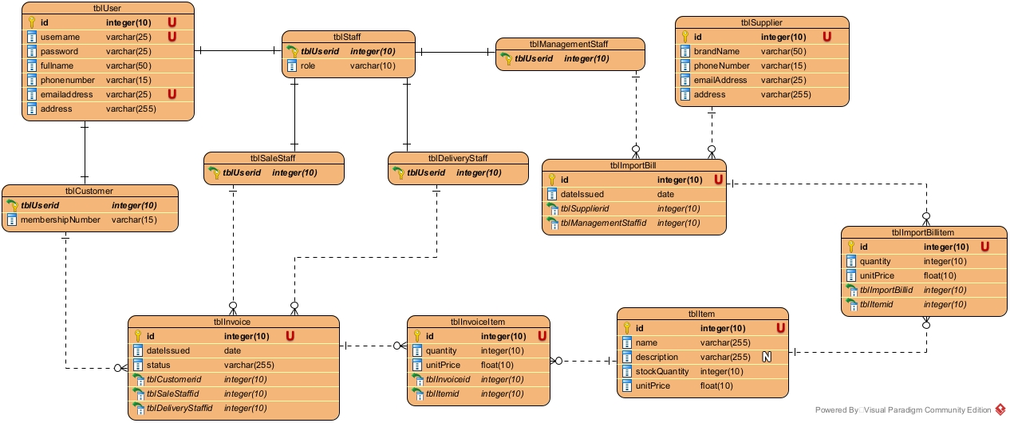

III. Class Diagram (Design)
Interface Design:

HomePageView.jsp
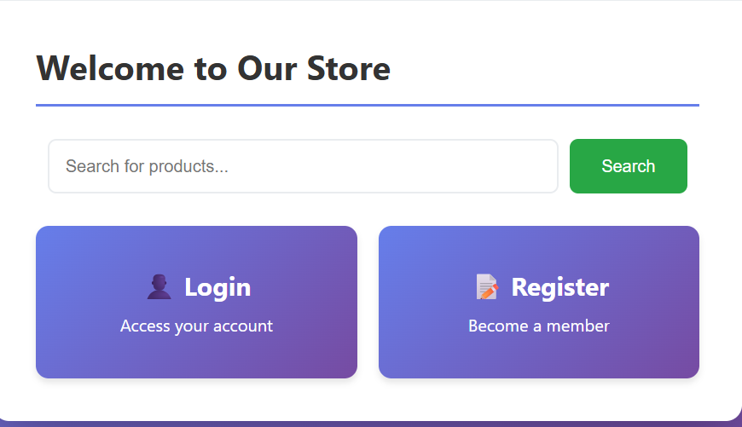

RegisFormView.jsp
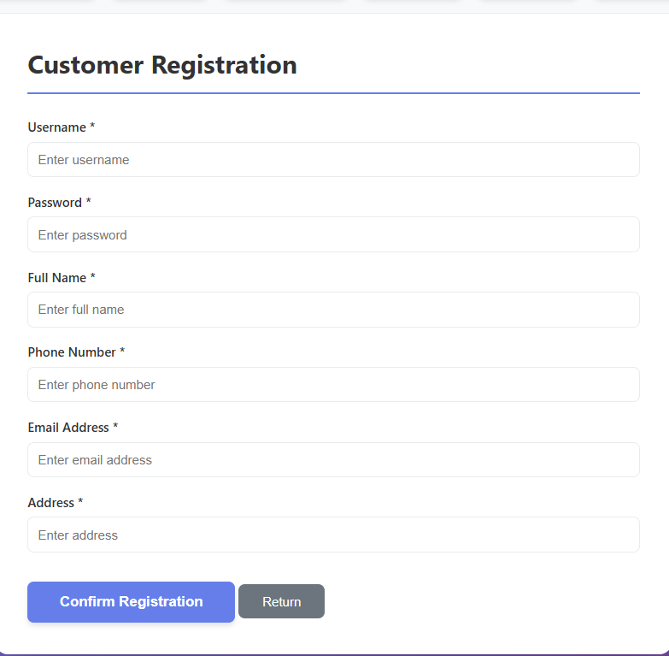

ManagementStaffHomeView.jsp
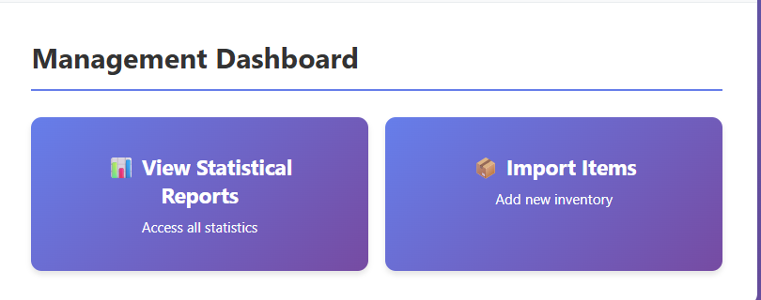
StatView.jsp
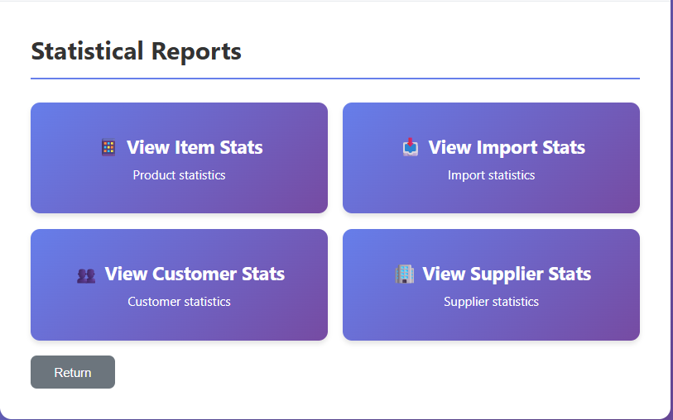

ItemStatView.jsp

InvoiceView.jsp

Module Customer registers as a member:
- The interface (View) class consists of these jsp view: HomePageView, RegisFormView
- The control class: CustomerController
- The data access (DAO) class:
  - DAO is a general class of DAO. It has only construction to connect to the DB and provides the common connection for all inherited DAO classes in the system
  - CustomerDAO is the class for manipulating DB related to the Customer object. In this module, it needs a saveRegisterInfo method to save the register information of the customer to the DB. The input of this method is a Customer, and the output is boolean
- Entity class: all related entity classes from analysis
Diagram:
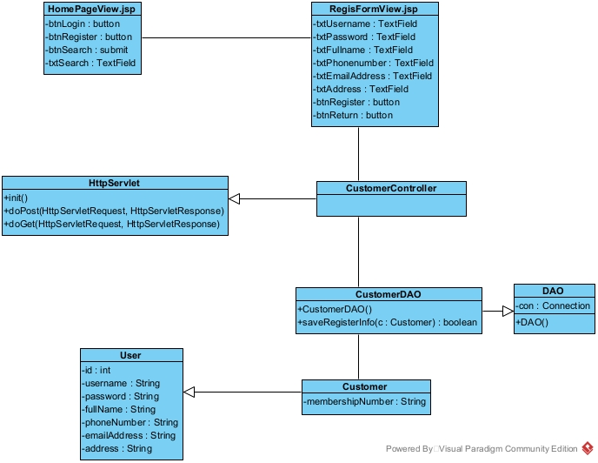
Module Management Staff view Item statistics:
- The interface (View) class consists of these jsp views: ManagementStaffHomeView, StatView, ItemStatView, InvoiceView
- The control class: ExportStatController, InvoiceController
- The data access (DAO) class:
  - DAO is a general class of DAO. It has only construction to connect to the DB and provides the common connection for all inherited DAO classes in the system
  - ExportStatDAO is the class for manipulating DB related to the ExportStat object. In this module, it needs a getExportStatByDate() method to get the required statistics from the DB. The input of this method is start date and end date, and the output is a list of ExportStat
  - InvoiceDAO is the class for manipulating DB related to the Invoice object. In this module, it needs a getInvoiceListOfItem() method to get the related Invoice statistics of selected Item from the DB. The input of this method is itemId, start date and end date, and the output is a list of Invoice
- Entity class: all related entity classes from analysis
Diagram:
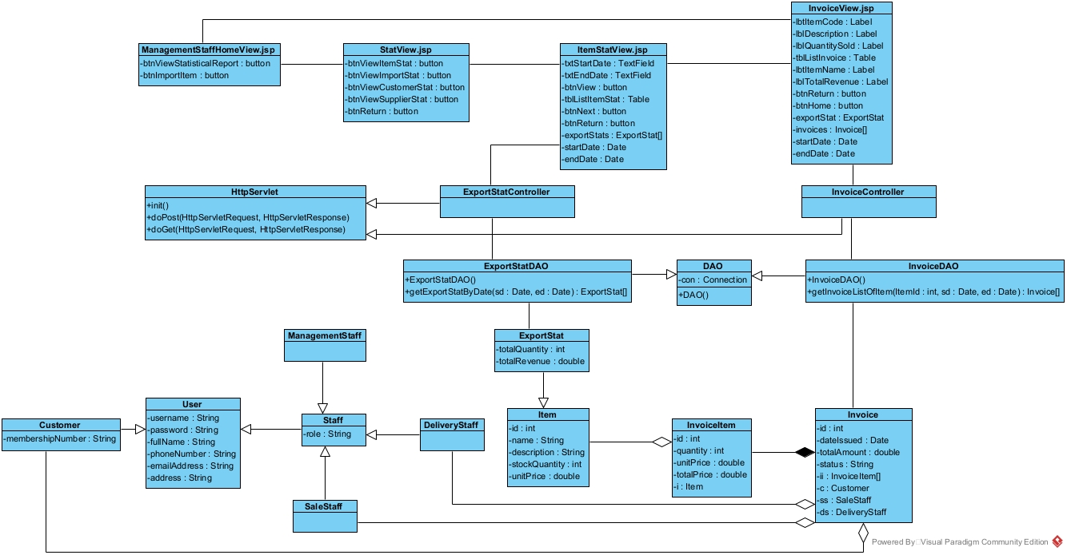

IV. Activity Design
Module Customer registers as a member:
Scenario v3:
1. At the HomePageView.jsp, customer chooses the option “Register” to register as a member
2. HomePageView.jsp calls RegisFormView.jsp
3. RegisFormView.jsp displays itself to the customer
4. Customer fills in all the registration information and clicks register
5. RegisFormView.jsp calls CustomerController
6. CustomerController calls method doPost()
7. doPost() calls class Customer to create a Customer object
8. The class Customer packs the register information into a Customer object
9. Customer return the newly created object to doPost()
10. doPost() transfer the object and calls CustomerDAO
11. CustomerDAO calls method saveRegisterInfo() to saves the registration information of the customer to the DB
12. saveRegisterInfo() returns the result to CustomerController
13. CustomerController return the resutl to RegisformView.jsp
14. RegisFormView .jsp informs success to the customer
Activity Diagram:
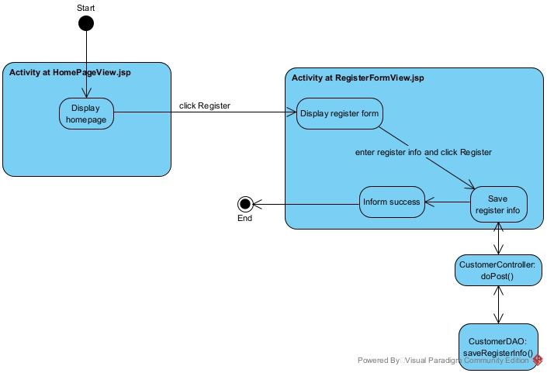
Sequence Diagram:
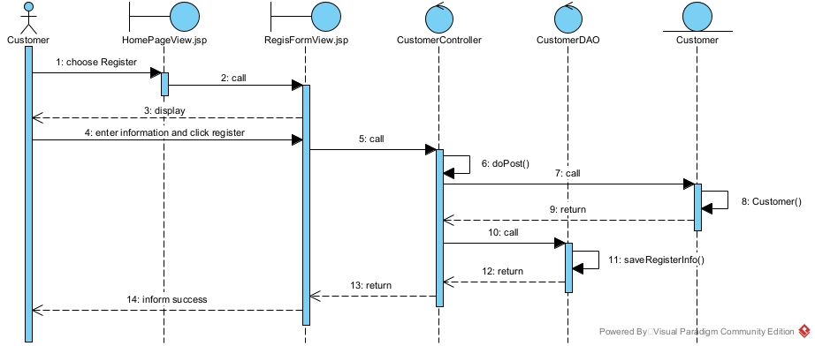
Module Management Staff view Item statistics:
Scenario v3:
1. At the ManagementStaffHomeView.jsp, after login, management staff chooses the option to view statistical reports
2. ManagementStaffHomeView.jsp calls StatView.jsp
3. StatView.jsp displays itself to the management staff
4. Management staff chooses the option to view items stat
5. StatView.jsp calls ItemStatView.jsp
6. ItemStatView.jsp displays itself to the management staff
7. Management staff enter start and end date, then click on View
8. ItemStatView.jsp calls ExportStatController
9. ExportStatController calls method doGet()
10. doGet() transfer the input date and call ExportStatDAO
11. ExportStatDAO call methods getExportStatByDate()
12. getExportStatByDate() execute and call the class ExportStat to encapsulate information
13. Class ExportStat encapsulates its normal attributes
14. Class ExportStat returns the result to getExportStatByDate()
15. getExportStatByDate() returns the result to ExportStatController
16. ExportStatController returns the result to ItemStatView.jsp
17. ItemStatView.jsp displays the result to the management staff
18. Management staff clicks on an item, then click next
19. ItemStatView.jsp calls InvoiceView.jsp
20. InvoiceView.jsp calls InvoiceController
21. InvoiceController calls method doGet()
22. doGet() transfers the selected Item and calls InvoiceDAO
23. InvoiceDAO calls method getInvoiceListOfItem()
24. getInvoiceListOfItem() executes and call the class Invoice to encapsulate information
25. Invoice encapsulates its normal attributes
26. Class Invoice calls the class Customer to pack its object attribute
27. Class Customer packs its attributes
28. Class Customer returns the packed object to the class Invoice
29. Class Invoice calls the class SaleStaff to pack its object attribute
30. Class SaleStaff packs its attributes
31. Class SaleStaff returns the packed object to the class Invoice
32. Class Invoice calls the class DeliveryStaff to pack its object attribute
33. Class DeliveryStaff packs its attributes
34. Class DeliveryStaff returns the packed object to the class Invoice
35. Class Invoice calls the class InvoiceItem to pack its object attribute
36. Class InvoiceItem packs its normal attributes
37. Class InvoiceItem calls the class Item to pack its object attribute
38. Class Item packs its aatributes
39. Class Item returns the packed object to the class InvoiceItem
40. Class InvoiceItem returns the packed object to class Invoice
41. Class Invoice returns the result to getInvoiceListOfItem()
42. getInvoiceListOfItem() returns the result to InvoiceController
43. InvoiceController returns the result to InvoiceView.jsp
44. InvoiceView.jsp displays the result to the management staff
Activity Diagram:
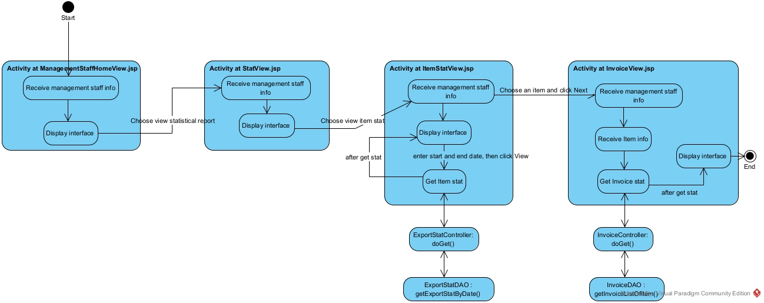
Sequence Diagram:
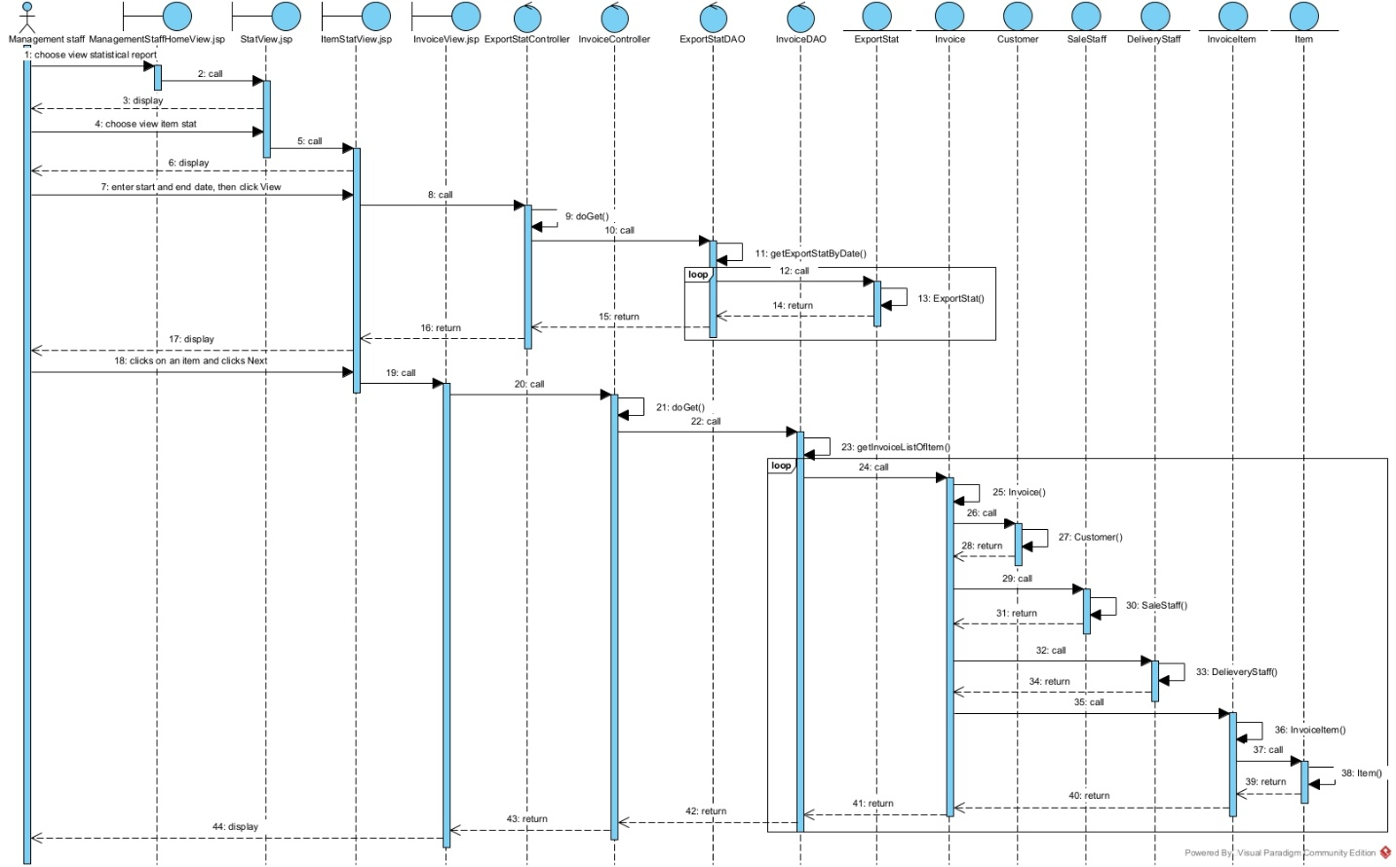

V. Deployment Design
The project structure is design based on the following picture, with entity class in folder Model, view class in folder View (4 separate folders for Customer, ManagemenStaff, SaleStaff and DeliveryStaff), controller class in folder Controller and DAO class in folder DAO
Package Diagram for the system:
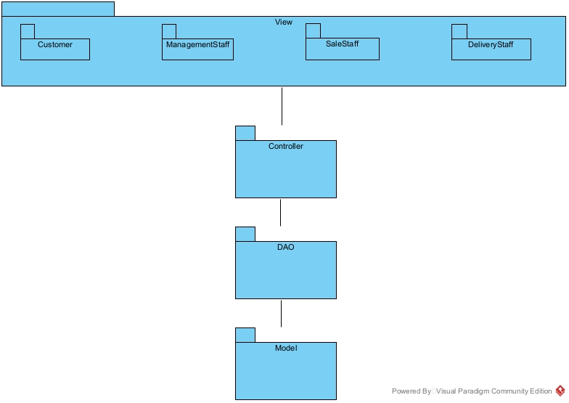
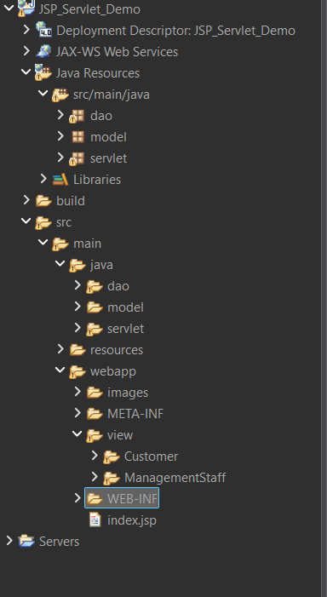

Deployment Diagram:
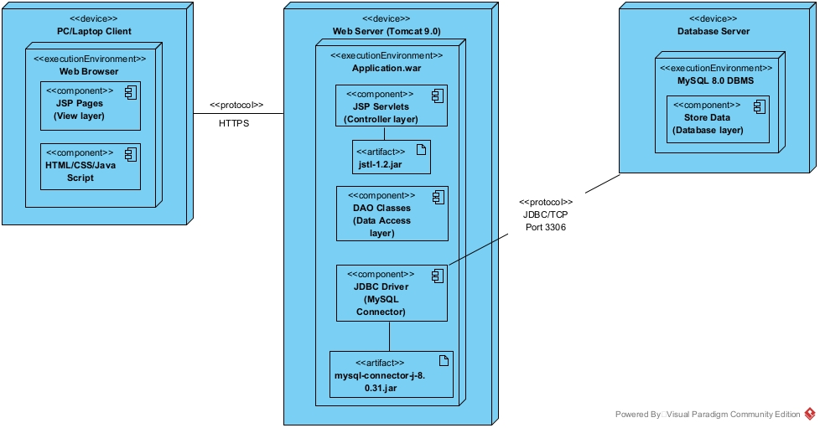

D. Coding

Link Github: https://github.com/Phongdzfk/PTTK-35B22DCCN612/tree/main

